

**Age**

**Brave**

**Calm**

**Emergency**

**Help**

**Hero**

**Location**

**Name**

**Op**

**Rader**

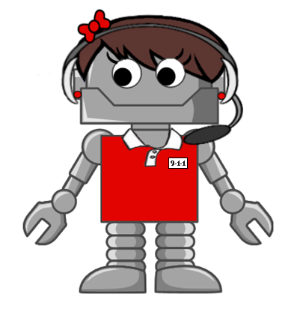

Op has been studying hard to learn all the important words related to 9-1-1.

Help her find all the words that are hidden below.

